**Topic:** Great Theorem, Quadrature of the Lune

**Notes on Topic:**

A lune, to put it simply is a crescent

Hippocrates squared a specific type of lune

The result rested upon three preliminary results

* The pythagorean theorem
* An angle inscribed in a semi-circle is a right angle
* The area of two circles or semi-circles are to each other as the squares on their diameters

This last notion is a little strange to abstractly think about. It means:

$\frac{Area (semi-cricle1)}{Area (semi-circle2)}=\frac{D_{1}^{2}}{D_{2}^{2}}$

This is a sophisticated proposition that Hippocrates claimed to prove, but there was no such proof to be found, until Euclid tackled this proposition in Book XII of the Elements

Hippocrates tackled this problem in a concise and constructed manor.

Start with a semi-circle having center O and radius $\underline{AO}$ = $\underline{OB}$

Construct OC perpendicular to AB with point C on the semi-circle, then draw lines AC and BC.

Bisect AC at D, using $\underline{AD}$ as the radius and D as center, draw semi-circle AEC thus creating lune AECF.

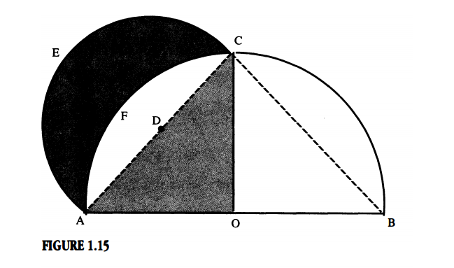

Hippocrates was to show that the lune in question had the same area as shaded $Δ$ AOC. He then could apply the previous theorem to show that the lune is quadrable.

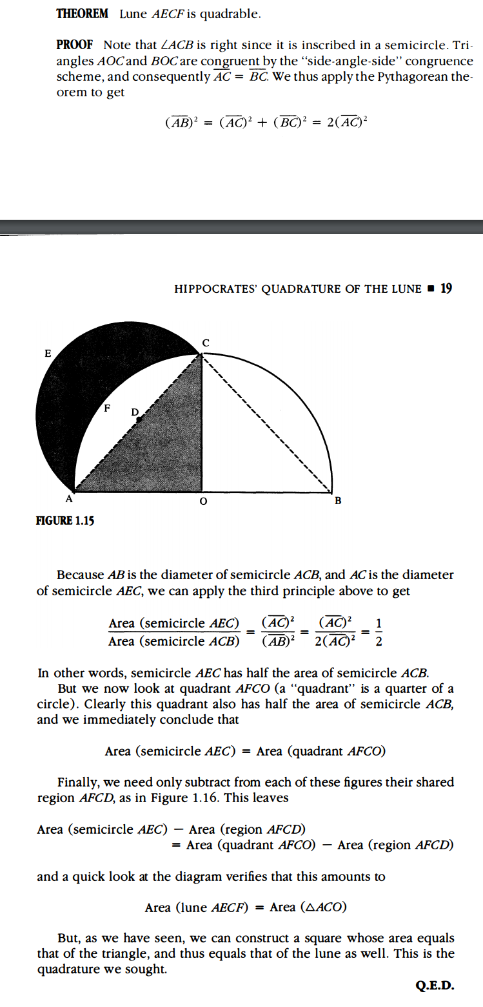

**In Class Discussion:**

Homework Problem 6

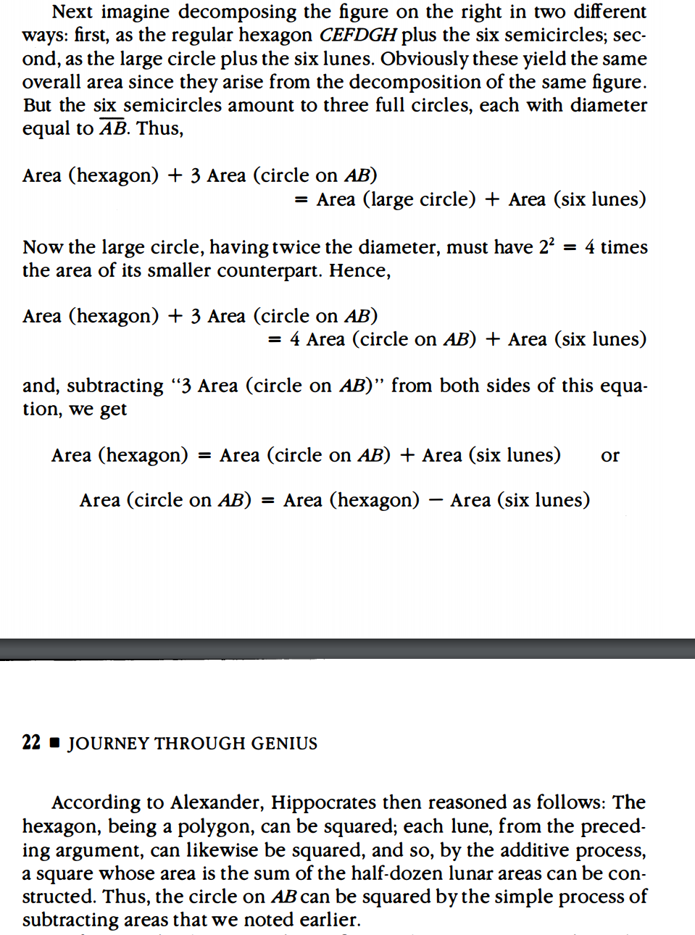

Discuss: Where was Hippocrates fault? There is a flaw in this argument.

The Quadrature of the Circle is impossible: this proof is from long past Hippocrates time, the use of pi in the proof is critical, but this constant was not available for use in Hippocrates time.

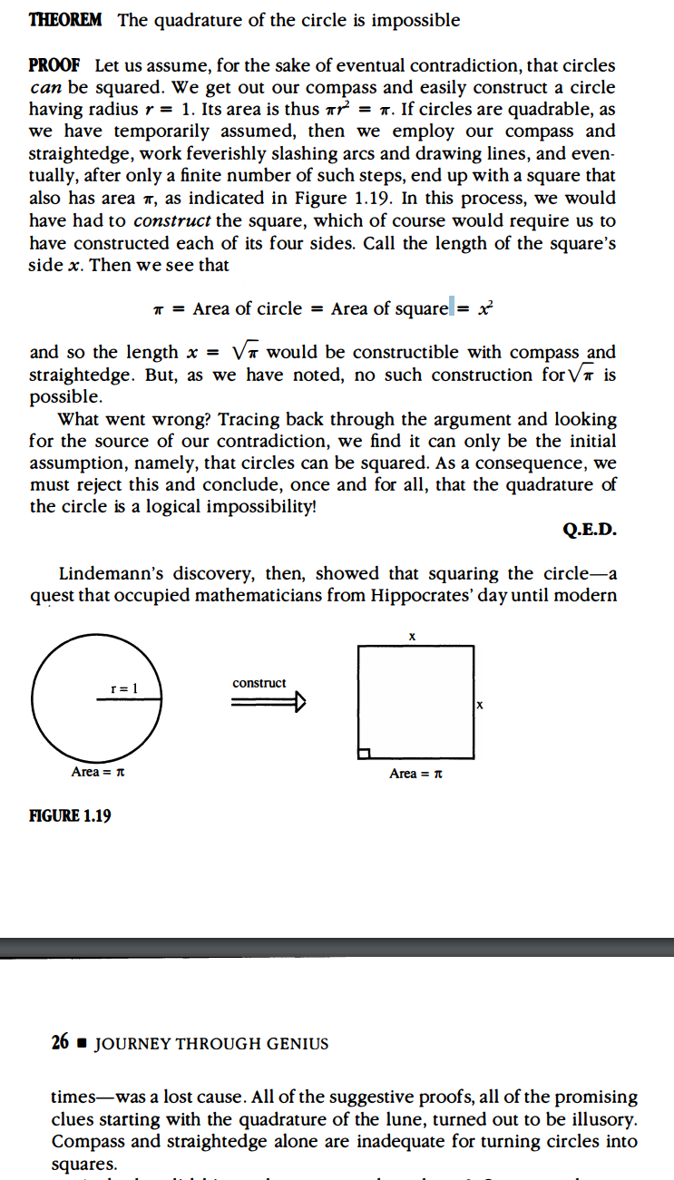

**Additional Suggested Reading**: N/A

**Assignment:** Read Epilogue, Homework Problems 7, 8, 11, 13